The Academy Awards:
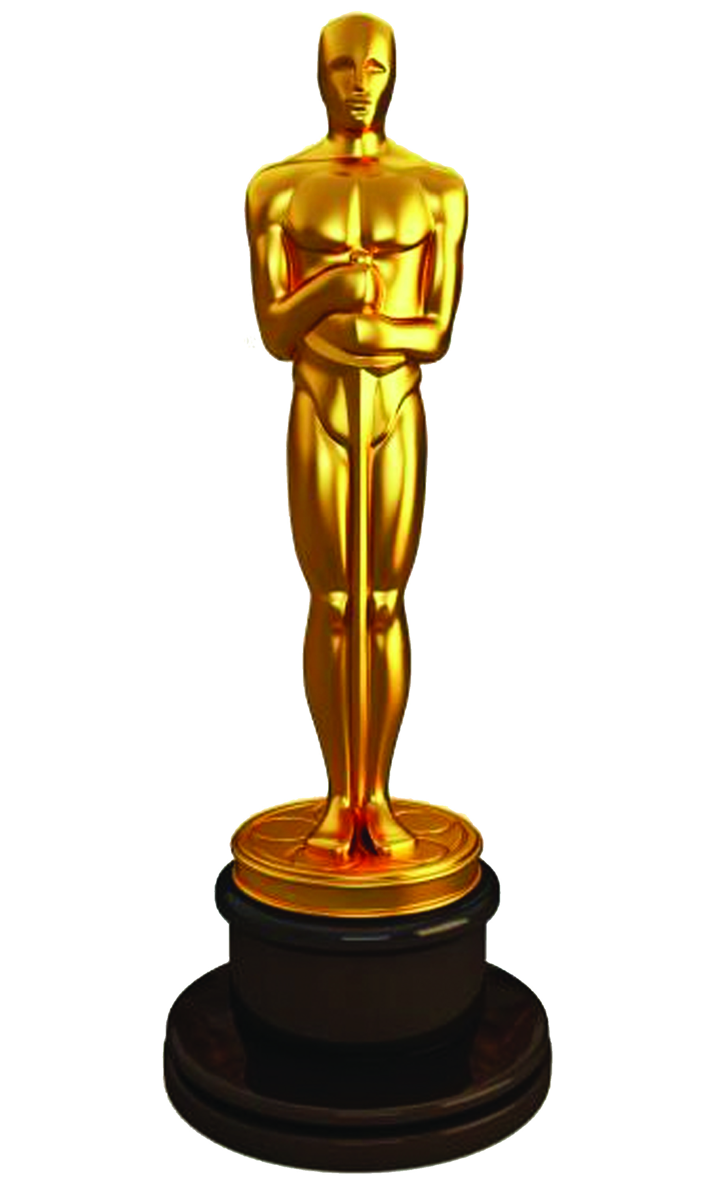
What Were The Best Moments of the Past Five Years?
Page 1: Intro

Page 2: Awards

Page 3: Hosts
Page 4: Special Events
Page 5: Bloopers
Page 6: Issues
Watching the Oscars a month ago got me thinking: What are some interesting highlights that took place in the last few shows? This informative link will give you insight on some very important memories from the last five years of Hollywood’s biggest night of the year. From Ellen DeGeneres’ selfie, to Jennifer Lawrence falling on the stage steps when receiving an award, TWICE! Enjoy my favourite moments!
Your author, William Krovats

What Awards Are Given Out?

This is a list of awards that filmmakers, actors and directors are recognized for. And as a bonus, we’ll show you the past five Best Pictures! Here:

- Best Original Screenplay
- Best Adapted Screenplay
- Best Visual Effects
- Best Sound Mixing
Best Pictures
2017- Moonlight (almost La La Land)
2016- Spotlight
2015- Birdman(The Unexpected Virtue of Ignorance)
2014- 12 Years a Slave
2013- Argo

- Best Sound Editing
- Best Short Film (Live-Action)
- Best Short Film (animated)
- Best Production Design
- Best original Song
- Best Original Score
- Best Makeup and Hairstyling
- Best Foreign Language Film
- Best Film Editing
- Best Documentary (Short Subject)

- Best Documentary(Feature)
- Best Director
- Best Costume Design
- Best Cinematography
- Best Animated Film
- Best Supporting Actress
- Best Supporting Actor
- Best Actress
- Best Actor
- Best Picture!
Who Has Hosted?
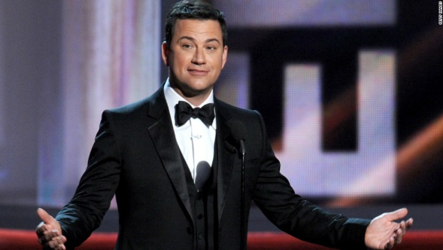
Here are the past five hosts of the Academy Awards, and their own flair that they brought to the show!
Jimmy Kimmel(2017)
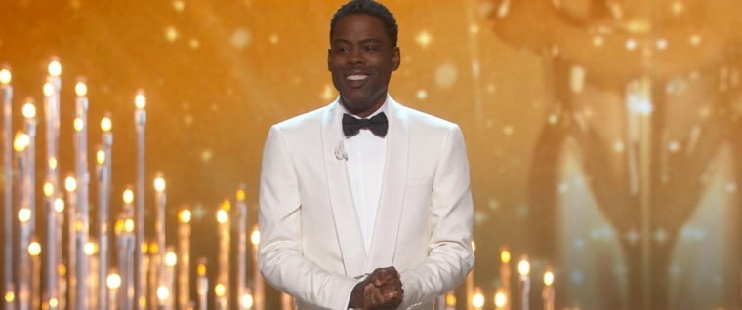
Jimmy got politics center stage saying that President Trump (boo!) would be tweeting angrily about a speech at his 5:00 bowel movement the next morning! That was my favourite line from that night! Get wrecked, Trump!
Chris Rock(2016)
Even with no black nominees, Chris made his show a night to remember, saying he was glad not to be playing 2nd place to Kevin Hart! No offense!
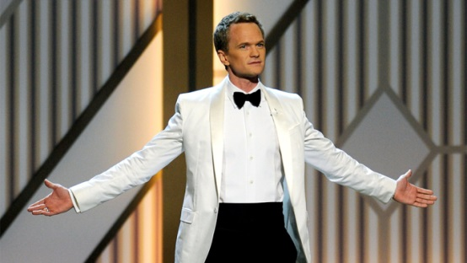
Neil Patrick Harris(2015)
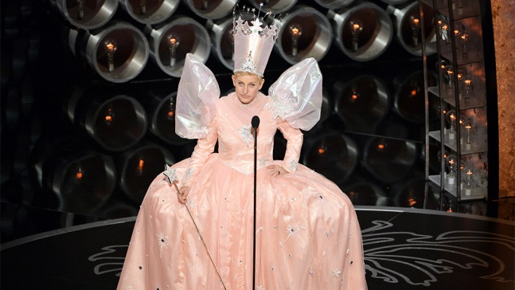
Neil brought Broadway to the stage in his opening, including an appearance from Cinderella (Anna Kendrick) who threw her Jimmy Chu at Jack Black! Well, he was criticizing their musical number!
Ellen DeGeneres(2014)
Ellen brought warmth from her talk show, and a little pizza to her ceremony, even paying tribute to the 75th anniversary of The Wizard of Oz by coming out dressed as Glinda!
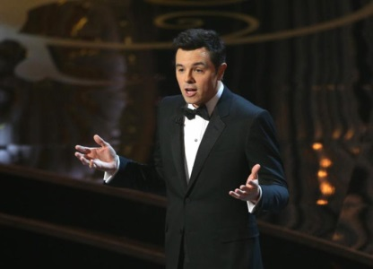
Seth MacFarlane(2013)
Appearing in movies such as Sing and Tooth Fairy, Seth made everyone feel welcome and funny at his show.
What Were Some Special Events?
Here are some interesting things that the hosts put into their performance.
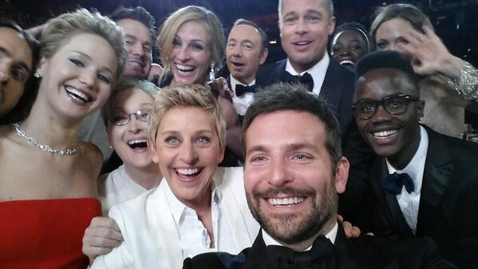
The Record Selfie
Ellen DeGeneres and 11 A-list actors nominated that night broke the record for the largest selfie posted on Twitter.
Here it is:

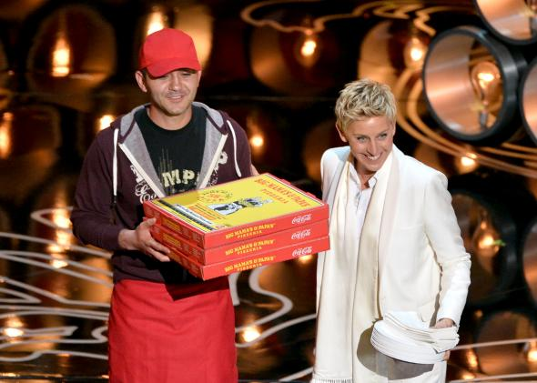
Pizza Anyone?
Ellen also did a kindness for the audience: She brought in pizza for anyone who wanted. in fact, Ellen has had the pizza guy on her show once in a blue moon!

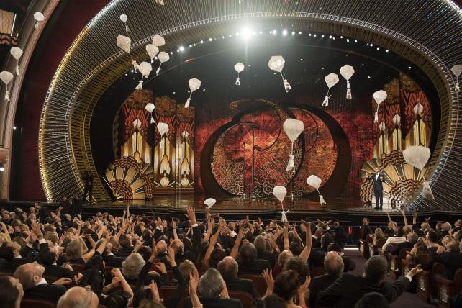
It’s Raining Candy!
Jimmy Kimmel didn’t have a pizza delivery, but rather candy parachutes raining from the roof! #sugarbuzz!

What Were the Funniest Bloopers?

Everyone makes mistakes! That’s certainly true for these actors who goofed up at the Oscars.
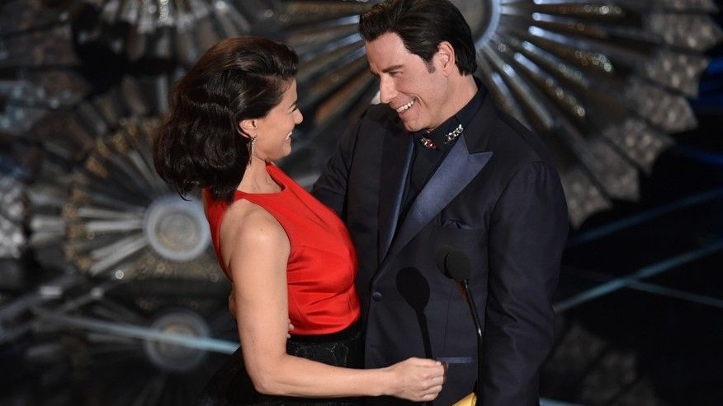
John Travolta

John Travolta, when introducing Idina Menzel, completely mispronounced her name. Idina got him back next year!

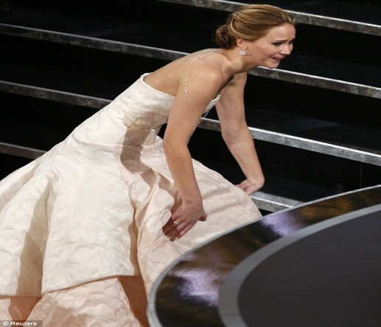
Jennifer Lawrence

Jennifer Lawrence, when receiving an award, she fell up the stairs, twice, mind you! Luckily, she wasn’t hurt at all.

Warren Beatty and Faye Dunaway
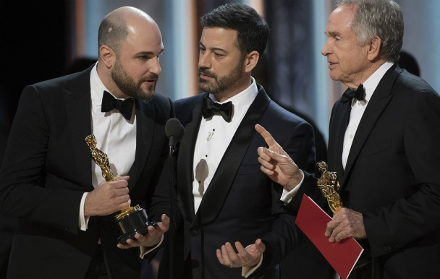
This is the biggest and most recent blooper. When announcing the winner for Best Picture this year, they read the wrong envelope! Big blunder!
Issues

Here are some things that cause problems during the biggest awards show in America and my opinion on them:

Voting

Other than the People’s Choice Awards and Kid’s Choice Awards, all the other award shows have judges from the Academy that choose what awards get won by movies. I personally would like to be able to vote for my favourite films. But I wonder if you have to be over 18 like you have to be over 18 to vote for the next president (ahem Donald Trump).

Politics

Speaking of presidents, at this year’s Oscars show, as previously mentioned, Jimmy Kimmel and so many others talked about the latest political events, and the butthead leader they’re forced to live under, Donald Trump. I know some people hate Trump’s guts, including me, but some people love him and worship him. And when I hear Donald Trump’s name on an awards show, and he gets roasted, I LIVE IT UP!

Where are all the Black Nominees?

Last year, all the nominees’ skin were as white at snow, and not as black as night. But black presenters and a black host! Why did that occur? It’s a mystery that will puzzle me forever. Maybe it’s because discrimination is immortal.
Works Cited

“Boutique Creative Agency NYC.” Nimble Division. 31 West 34 Street, Suite 8020, n.d. Web. 19 Mar 2017.

“The Oscars 2017, 89th Academy Awards.” Oscar.go.com. N.p., n.d. Web. 19 Mar. 2017

“US.” The Independent. Independent Digital News and Media, n.d. Web. 19 Mar. 2017.

